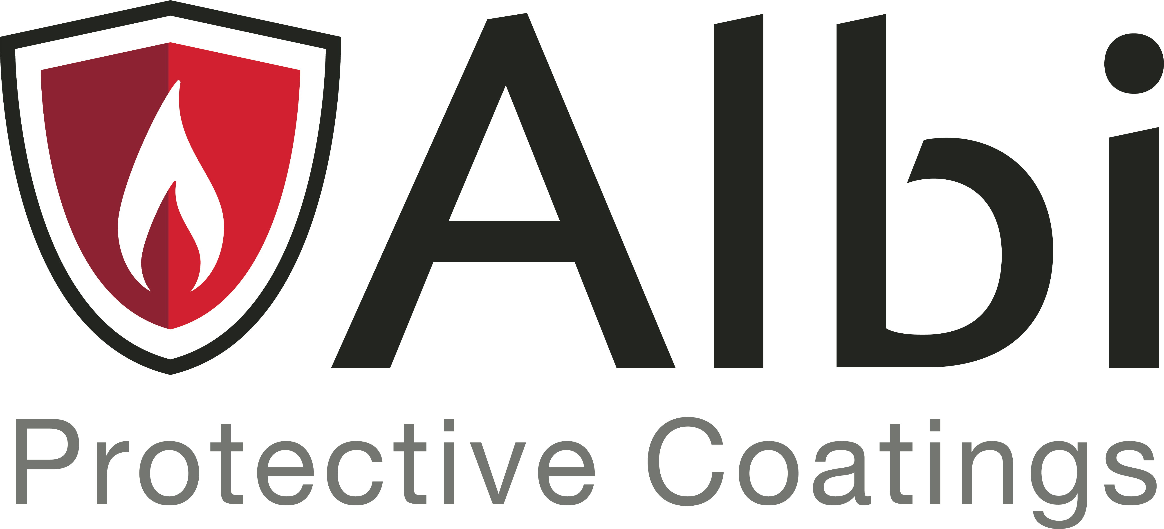
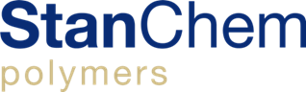
  - FOR IMMEDIATE RELEASE
STANCHEM POLYMERS ANNOUNCES ACQUISITION OF DUX

East Berlin, CT (January 4, 2021) – StanChem Polymers announced today that its wholly-owned subsidiary, Albi Protective Coatings, has completed the acquisition of Dux Paint and its sister companies, Hawthorne Coating and Hood Products (taken together, “Dux” or the “Company”).

Based in Lodi, New Jersey, Dux offers a differentiated and comprehensive portfolio of industrial protective coating solutions for refinish, wood, automotive and direct-to-metal applications. Founded over 70 years ago, Dux has built a reputation for superior-quality products, exceptional customer service, and technical expertise in the development of best-in-class solutions for its industrial customers.

Dux enhances Albi Protective Coatings’ technical capabilities and expands Albi’s intumescent and fire-retardant product lines into the broader industrial protective coatings market. Dux and its existing management team will continue to operate and serve its customer base from its facility in Lodi, New Jersey.

Howard Goldstein, former owner of Dux and new member of the Albi Protective Coatings senior leadership team, said, "We are excited to partner with Albi Protective Coatings given their deep expertise in the protective coatings sector and coating solutions for harsh environments. Our combined product offering, and brand recognition, will enhance our abilities to serve our customers who rely on us for their most challenging applications, and to accelerate growth in key markets and applications."

Paul Stenson, President and CEO of StanChem Polymers and Albi Protective Coatings, remarked, "We are delighted to welcome the Dux team to the StanChem-Albi family, and look forward to working with the Dux team in New Jersey to accomplish our vision of being a leading supplier of protective coatings for the most technically challenging field applied or OEM applications. The incorporation of Dux into the StanChem-Albi platform increases our scale, R&D / applications expertise and our ability to meet the needs of our growing customer base."

About StanChem Polymers:

Founded in 1968 and based in East Berlin, Connecticut, StanChem Polymers specializes in the development and manufacture of water-based emulsion polymers for coatings, adhesives, sealants, and elastomer applications. Albi Protective Coatings, a wholly-owned subsidiary of StanChem Polymers, develops and supplies a range of industry-leading protective coatings for fire-resistive and other mission-critical applications. Stanchem Polymers is a portfolio company of Artemis Capital Partners ("Artemis"), an industrial technology-focused private equity firm with expertise in the specialty chemicals industry.

For more information on StanChem Polymers, please visit: www.stanchem-inc.com
For more information on Albi Protective Coatings, please visit: www.albi.com
For more information on Dux Paint, please visit: www.duxpaint.com
For more information on Hood Finishing Products, please visit: www.hoodfinishing.com

--
Media Contact:
James F. Ward
Phone: (617) 830-1111
Email: jward@artemislp.com
##

